ZSB – SBMS 10.2013

INSTALL MANUAL

ZIP’S SMART BODY MODULAR INSTALLATION INSTRUCTIONS

READ INSTALLATION INSTRUCTIONS THOROUGHLY BEFORE INSTALLING UNIT TO PICKUP OR CHASSIS.

- SMART BODY MODULAR SERVICE

The following drawing illustrates the parts included in the SBMS. Check the contents of your kit before starting installation. SBMS can be customized to fit your specific needs – therefore your accual body may have a few variations.
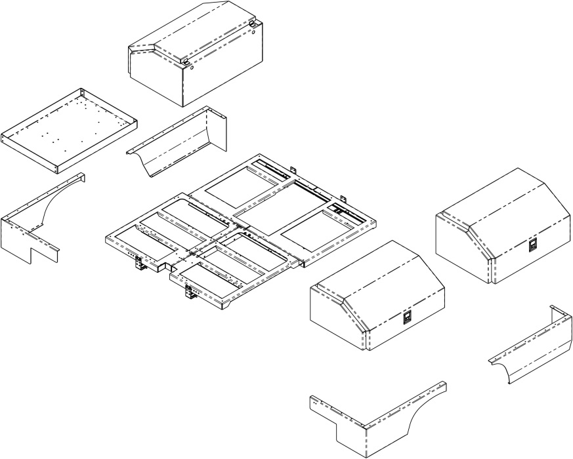

SMART BODY MODULAR SERVICE (SBMS)
SUBFRAME

TOOLBOXES & TRAYS

SKIRTING / FENDERS

REAR BUMPER (Not Shown)
- Prepare truck frame for:

DISCONNECT CHASSIS BATTERY TERMINALS BEFORE WELDING AND/OR PLASMA CUTTING (ELECTRICAL ARC) OF ANY METAL THAT IS GROUNDED TO CHASSIS. FAILURE TO DO SO MAY RESULT IN CHASSIS COMPUTER AND/OR ELECTRICAL SYSTEM DAMAGE.

  - Remove tail lights from chassis.

  - Some cabs have vents or features that sit further back than the sheet metal at the back of cab. The clear back of cab should be measured to these obstructions.

  - The SBMS is an eight (8) foot body that can be configured to fit both 56” and 60” CA.

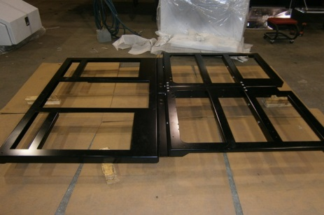
- SUBFRAME

  - Assemble the subframe completely on the ground. Remember to insert all (3) Crossmembers prior to bolting up.
(Shown in Figure 1)

  - Front tool boxes will be 2.125" in front of subframe. Allowing a minimum of 1.5" to back of cab, install subframe a minimum 3.625" from back of cab.

  - Additional space may be needed for accessories; the subframe may be moved back. Be sure to check clearance for tire travel.
Figure 1
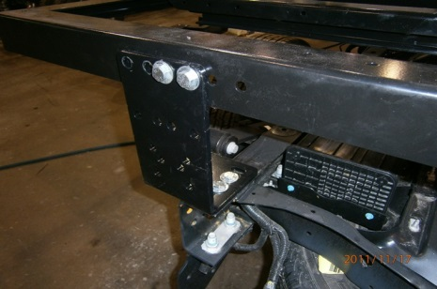
  - ALL CHASSIS - Rear “L” mounting brackets will bolt up; adjust both front and middle mounting brackets to achieve level.
( Shown in Figure 2)

  - PICK UP TRUCKS – FORD/DODGE Rear “L” mounting brackets will bolt up; adjust both front and middle mounting brackets to achieve level.
Figure 2
  - PICK UP TRUCKS – CHEV/GMC Rear “L” mounting brackets will bolt up; adjust both rear and middle mounting brackets to achieve level.
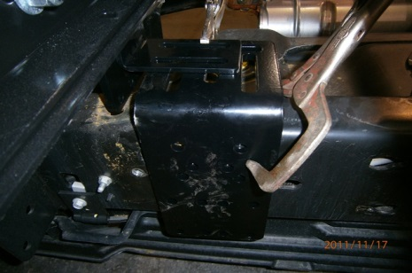
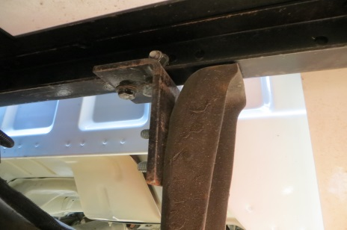
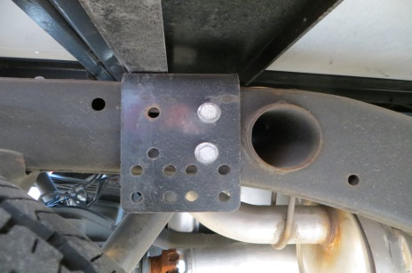
Middle Mount
Front Mount CHEV/GMC Pickup Only
Front Mount FORD/DODGE/CHEV Chassis

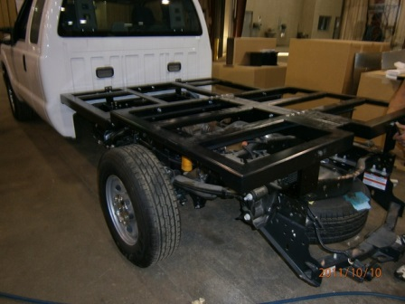

NOTE: Subframe must be level to ensure that body rides level when loaded and boxes don’t pitch together.
- Install wiring harness. Refer to front and rear harness schematics and electrical diagram.
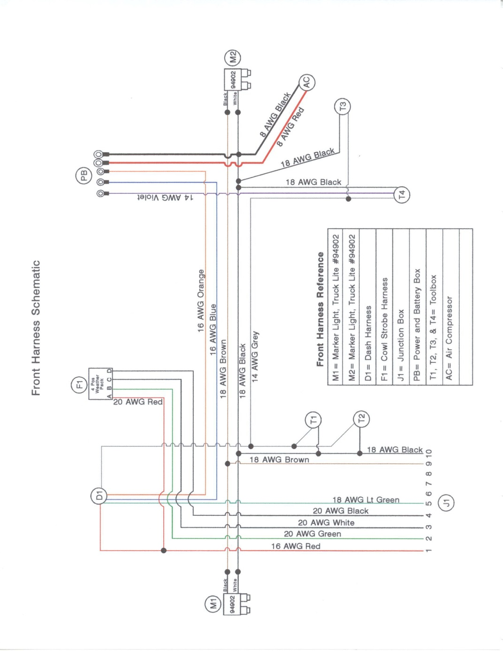
  - Install supplied wiring harnesses routing under the subframe.

- TOOLBOXES & TRAYS
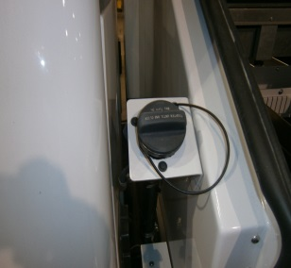
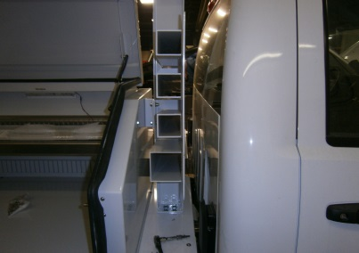
  - Front boxes are 23” tall and are available in 48, 45, 42, and 40 lengths.

  - Depending on which side the fuel fill is; a shorter box may be used to allow for fill between cab and box. *A filler plate is used to cover subframe where box is shortened.
Headache Rack w Storage
Fuel Fill between Cab & Toolbox
  - A white angle with holes for the fill assembly is provided

d. Install the provided 3" wide glue-backed rubber isolating strips on flat surfaces of the subframe to separate aluminum box from steel subframe.

e. Insert bulkhead fitting in left corner of left front box for
toolbox light wire.

f. Bolt box down with 4 bolts.
SBMS with 2 Front Toolboxes Mounted
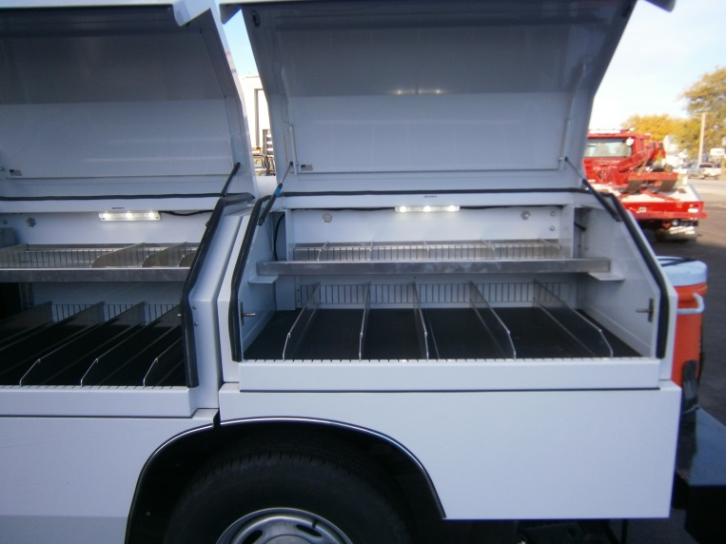
g. Insert gray circular grommet in right front
corner of each passenger side boxes and
insert toolbox light wire.

h. On the rear passenger side box, also install
the charge wire for hand tools.
All Toolboxes are shipped assembled, with built in Slots for adjustable dividers. *Lights and Shelving Optional
i. Install metal wire guards to protect box wiring.
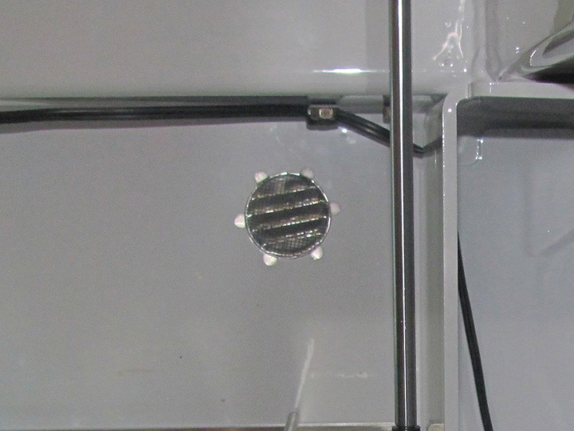
- Install the dividers inside the boxes.

- Install the box vents, bending the tabs to keep them in place.
(Shown in Figure 3)
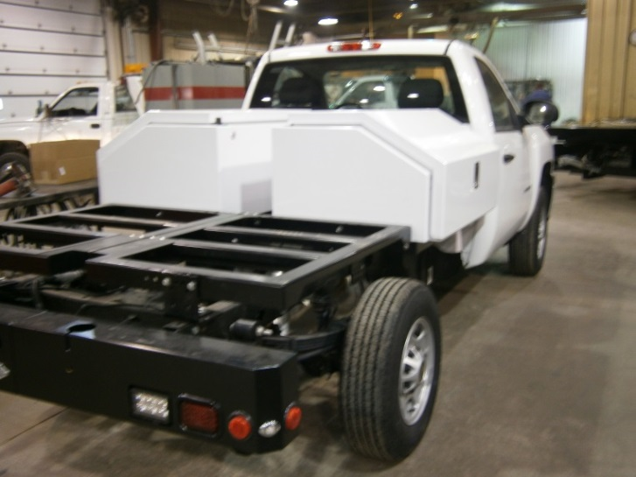
Figure 3

- SKIRTING / FENDERS

  - Install the 4 body skirts. Screws are provided. A predrilled 2" welting is provided to separate boxes from side panels. Note: Caulk unused pre drilled holes to weather proof box from underbody spray

  - Install push-on chrome trim around wheel wells.

  - Brace bars are provided to brace the corners in front of the wheel wells and small brackets brace the corners at the rear of the wheel wells to the mud flap brackets.

d. Install the aluminum two-piece mud flap brackets and the mud flaps. The mud flap
bracket may have to be notched to clear suspension components depending on the chassis.

- REAR BUMPER – Install bumper prior to placing rear toolboxes and skirting on subframe.
  - Note; Toolboxes and Skirting will extend 2.125”

  - Assemble Bumper prior to installing on truck.
- Rear Bumper Kit w/o Center PC
ZB110745
- Work/Backup Lights LED 4x6
MWL-04 (2)
Must install Diode for Work/Backup Lights to function properly
- Side Marker Lights
10255R LED, RED 2 ½” Reflect (4) 10702 Grommet, 2 ½” Closed Back (4)
- Stop/Turn/Lights
M42200R STT LED RED (2)
M45799 Grommet 3 ½”x 5” (2)
- License Plate Light
430W
- Backup Alarm
12-0303061 Backup Alarm ECCOMS97
- Wiring Harness
ZBT110683
- Wire Junction Box
- Plug - 7 Wire
755-1526 Plug, 7 Wire, Female, RV Style
- Socket
CR – 6 Socket, (4) Four way

  - Install the backup alarm at the rear near the junction box.

  - Install the rear bumper approximately 1" to the rear of body skirts.

  - ”L” Mounting Bracket pre-drilled to allow for adjustment
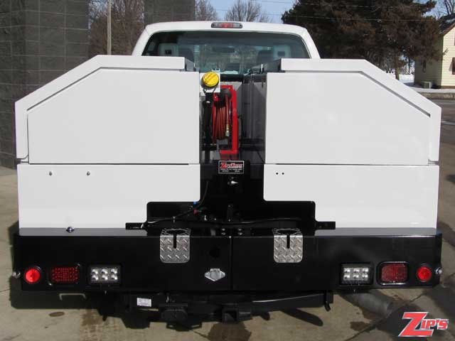
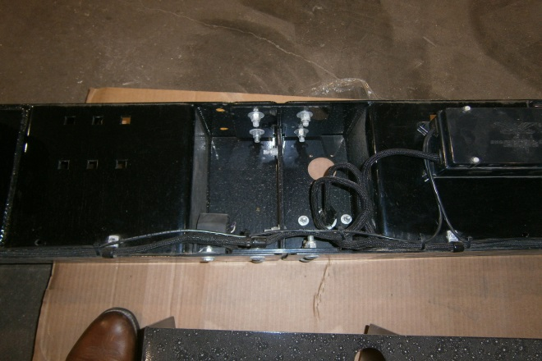

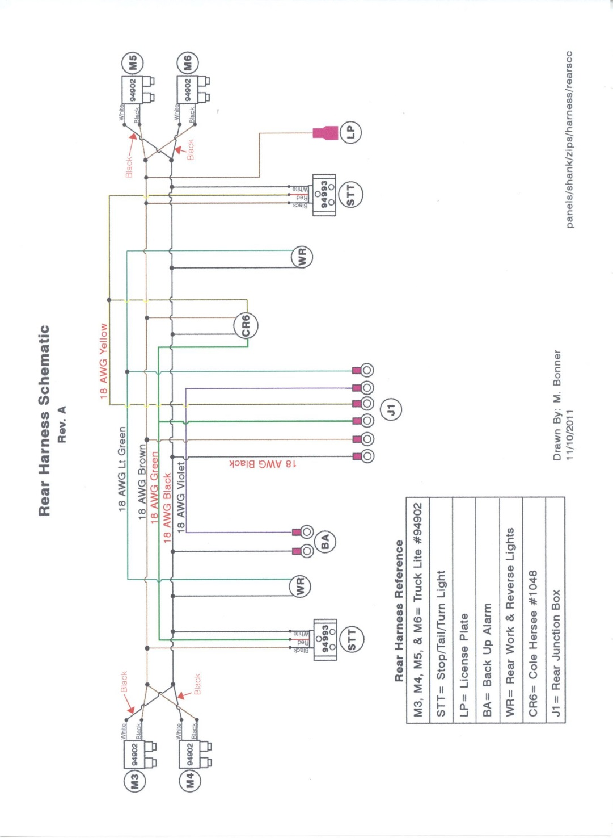

8. CENTER AREA OPTIONS

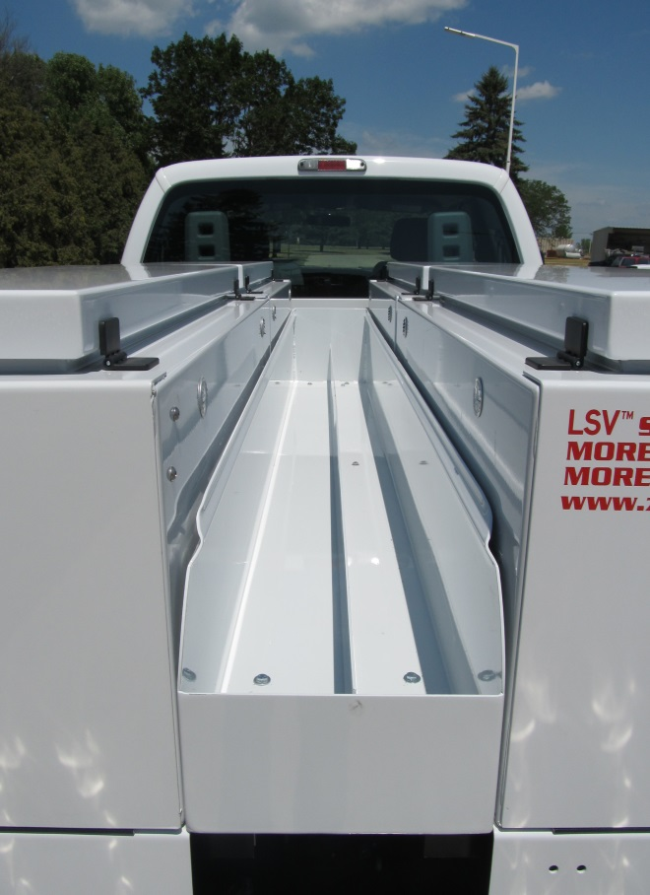
- SBMS – Center area between toolboxes or trays is usually a 12” x 96” space.

- Aluminum Fixed Tray 12”x96” with 12” sides and slots for tie downs. 6 bolt with spacers for front drop. Comes with a 96” adjustable divider (See Figure 4)

- Aluminum Sliding Tray 12”x96” with 12” sides and slots for tie downs. 6 bolts fasten to 6” slider. (See Figure 5 & 6)

Figure 5

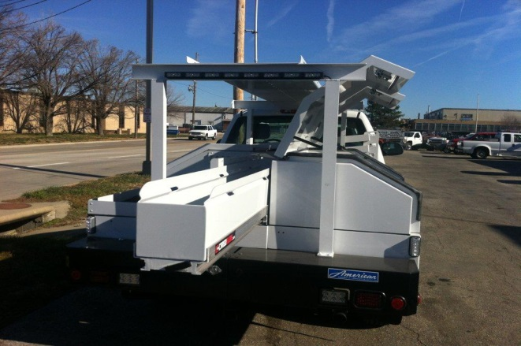
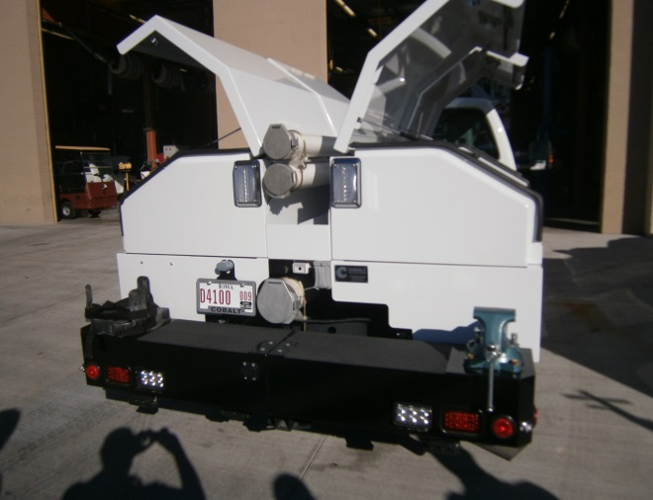

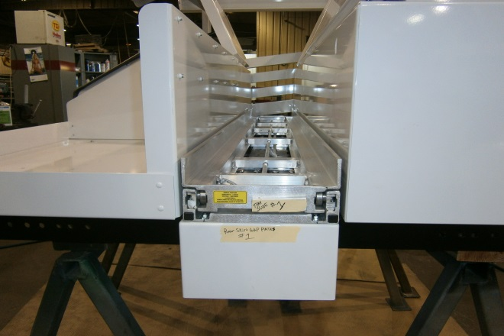
- Customizable to fit specific needs (See Figure 7)
FOR PARTS OR TECHNICAL SUPPORT
PLEASE CALL 800-222-6047
ASK FOR PARTS
316 WEST MILWAUKEE STREET
NEW HAMPTON, IOWA 50659
WWW.ZIPS.COM
Figure 7
Figure 6
Figure 4

